



MICROSOFT ARCHITECTURE BEST PRACTICE FOR CLOUD AI PLATFORM

USECASE: AKS BASELINE FOR MULTIREGION CLUSTERS

Document Title | Microsoft Cloud Center of Excellence Overview
Presales/Technical Head | Tushar Mehrotra/Rohit Pandey
CCoE Lead | Ravishankar N
Creation Date | December 2025
Version | Description | Modified by | Date | Approved by | Date
1 | Initial Architecture design | Ranu Kumar | 15/12/2025 | Ravi Shankar | 15/12/2025
Contents
1
1. Executive Summary 3
2. Scope and Applicability 3
3. Business Scenario Overview 3
4. Reference Architecture Overview 4
4.1 Architecture Description 4
5 Logical Architecture Components 4
5.1 Regional AKS Clusters 4
5.2 Networking and Regional Isolation 5
5.3 Global Traffic Management 5
6 Architectural Best Practices 6
6.1 Design for Regional Independence 6
10 Conclusion 7

AKS Baseline for Multiregion Clusters

Executive Summary
This document defines a standardized multi-region, multi-cluster reference architecture for Azure Kubernetes Service (AKS). It describes architectural patterns and best practices for designing, deploying, and operating AKS platforms that require high availability, regional resiliency, and global traffic distribution.
The architecture is curated and maintained as an internal platform standard to support mission-critical workloads that demand business continuity, disaster recovery, and consistent operations across multiple Azure regions.

Scope and Applicability
This reference architecture applies to:
- Business-critical and highly available Kubernetes platforms
- Applications requiring regional resiliency and disaster recovery
- Internet-facing and globally distributed workloads
- Microservices and API-driven architectures
- Enterprise production environments with strict availability requirements
The design supports active/active and active/passive topologies and can be adapted based on application characteristics, data consistency needs, and regulatory constraints.

Business Scenario Overview
Modern digital applications are expected to remain available despite regional outages, infrastructure failures, or planned maintenance events. Single-region Kubernetes deployments often introduce availability risks that are unacceptable for customer-facing or revenue-critical systems.
A multi-region, multi-cluster AKS architecture enables organizations to:
- Improve application availability and fault tolerance
- Reduce impact of regional Azure service disruptions
- Support global user bases with optimized latency
- Enable controlled disaster recovery and failover strategies
- Operate Kubernetes platforms at enterprise scale

Reference Architecture Overview

Architecture Description
The multi-cluster AKS architecture deploys independent AKS clusters in multiple Azure regions, with traffic distributed through global routing services. Each cluster operates autonomously while adhering to consistent platform and security standards.
High-Level Architecture Description
- AKS clusters are deployed in separate Azure regions
- Each cluster is isolated within its own virtual network
- Workloads are deployed consistently across clusters
- Global traffic routing directs users to healthy regional endpoints
- Failover mechanisms redirect traffic during regional outages
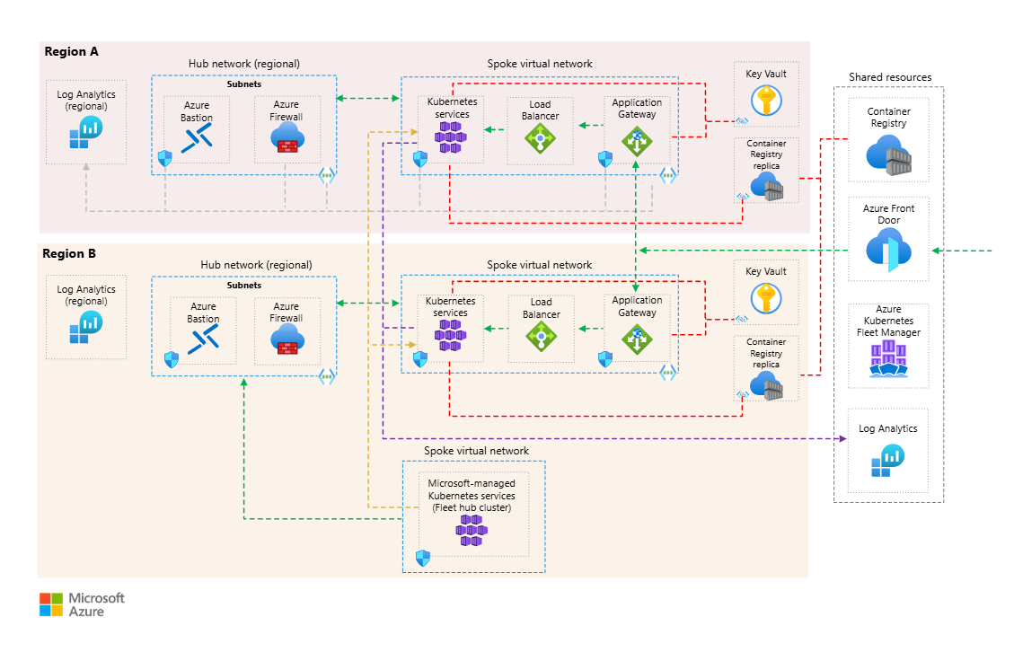

Logical Architecture Components

Regional AKS Clusters
Each Azure region hosts a dedicated AKS cluster with the following characteristics:
- Independent control planes and node pools
- Identical cluster and workload configuration baselines
- Isolation of failures between regions
- Local autoscaling, upgrades, and maintenance operations
Clusters are treated as separate failure domains to maximize resiliency.

Networking and Regional Isolation
Networking design emphasizes isolation and control:
- Separate virtual networks per region
- No direct dependency between cluster networks
- Controlled ingress and egress paths per region
- Network security policies applied consistently
This ensures that network-level issues in one region do not affect others.

Global Traffic Management
User traffic is distributed across regional clusters using global routing services. Key design considerations include:
- Health-based traffic routing
- Support for active/active or active/passive patterns
- Automatic failover during regional outages
- Optimized user routing based on geography
Traffic management is decoupled from cluster operations, enabling flexible failover strategies.
Application Deployment Model
Applications are deployed consistently across all clusters:
- Identical container images and deployment definitions
- Environment-specific configuration managed externally
- Stateless application design where possible
- Independent scaling behavior per region
This model simplifies operations while enabling regional autonomy.
Data and State Considerations
Data management strategies depend on workload requirements:
- Regional data stores for latency-sensitive workloads
- Geo-replicated data services where supported
- Clear separation of application state from compute
- Defined recovery objectives for stateful components
Data architecture is aligned with application consistency and recovery requirements.
Identity and Security
Security controls are applied consistently across regions:
- Centralized identity and access management using Microsoft Entra ID
- Role-based access control for clusters and namespaces
- Secure communication between services and dependencies
- Standardized secrets and certificate management practices
Security policies are enforced uniformly while allowing regional independence.
Observability and Operations
Operational visibility spans all regions:
- Centralized logging and metrics aggregation
- Health monitoring for clusters and workloads
- Alerts for regional degradation or outages
- Dashboards providing cross-region operational insight
This enables operations teams to detect, respond to, and recover from failures effectively.

Architectural Best Practices

6.1 Design for Regional Independence
- Treat each cluster as a standalone failure domain
- Avoid cross-cluster runtime dependencies
- Ensure clusters can operate independently during failures

6.2 Conclusion
The multi-region Azure Kubernetes Service reference architecture described in this document provides a resilient and scalable foundation for running distributed containerized workloads on Azure. By deploying independent AKS clusters across regions and implementing robust traffic management and operational practices, organizations can achieve high availability, fault tolerance, and global scale while maintaining consistent governance and security.

